Harvest
Friday 30th September 22
Today we talked about what is Harvest, why we celebrate it and how we celebrate it.
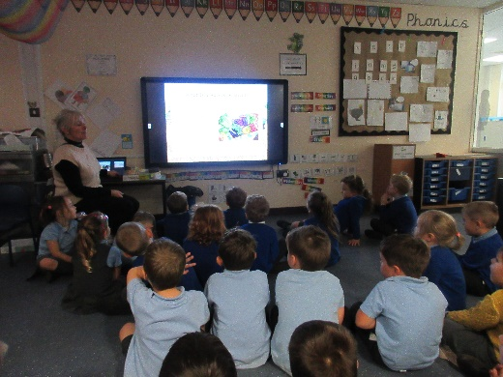
We began by looking at a PowerPoint that heled us to understand what Harvest was.

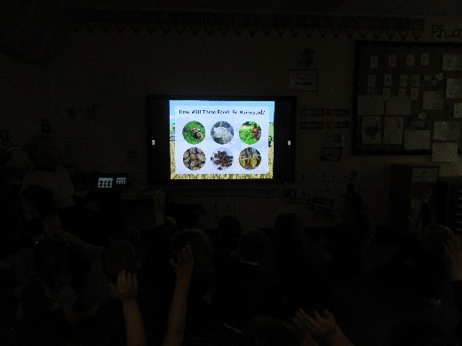

We looked at all the things that we harvest and what they are turned into, and we looked at he machinery the farmers use.

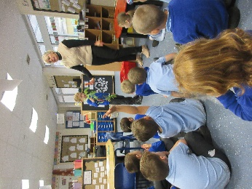
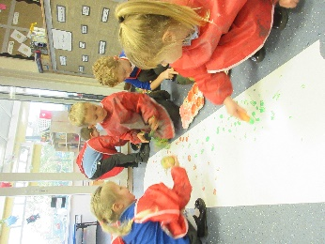
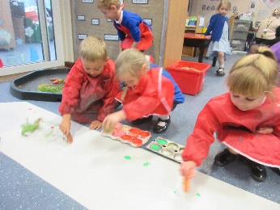
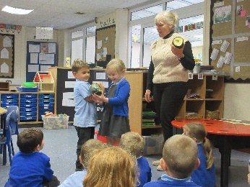
We investigated carrots, potatoes, and a marrow.

We used the vegetables to do some printing.

