Friday 7th October – Friday 14th October 2022
We began our topic on Space by watching the online story ‘Fly Me To The Moon’. We really enjoyed joining in with the story.
I think the moon is made of cheese.
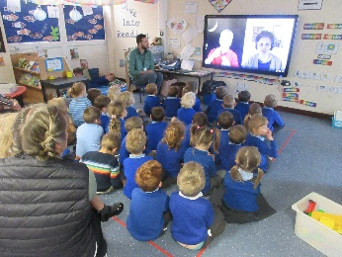
After listening to the story the children were so excited to learn more about Space. We made our own rockets and our own box that showed the different phases of the moon.
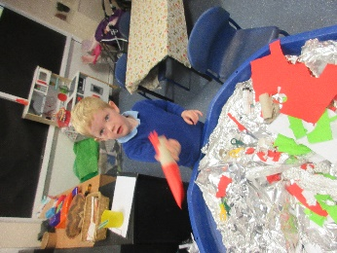
My rocket has flames.
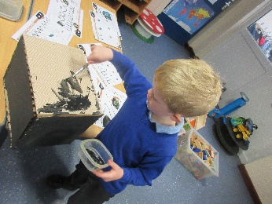

We then listened to the story ‘Whatever Next’, the children decided to make their own spaceships and space clothes.
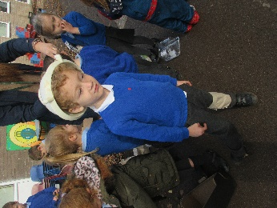
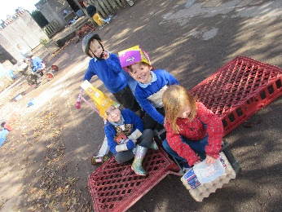
I’ve landed on the moon.

To help us understand what space is like we pretended to go in a spaceship to visit the different planets, we found out about Mercury, Jupiter, Mars, Uranus, and then we pretended to be Saturn and it’s rings. We even walked on the moon.
We’re going round and round.
