Thursday 13th October 2022
This afternoon we invited our families into school to help us plant some Spring bulbs, paint our sheds and tidy up the playground before Winter. We were very busy but had great fun. At the end of the afternoon, we shared some cookies that we had made and had a drink of squash.
We put some special soil in.

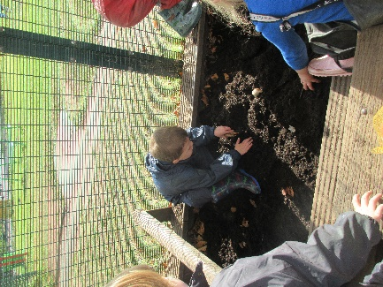
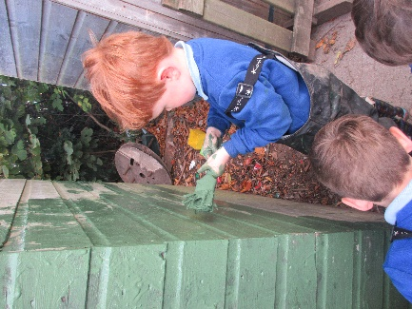
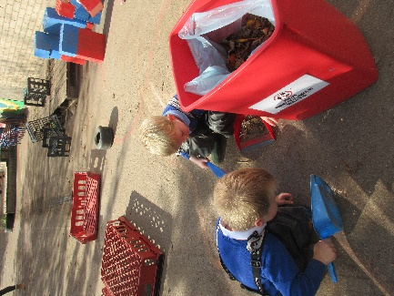
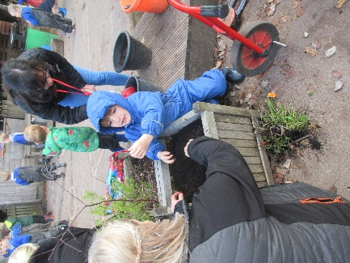
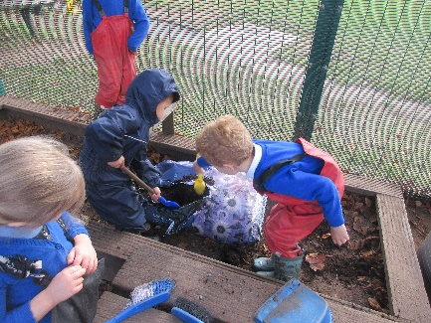

The flowers grow from this.
It’s messy.
Lots of leaves.
I found treasure.

