**Cleobury Mortimer Primary School:**

**Kestrel Class**

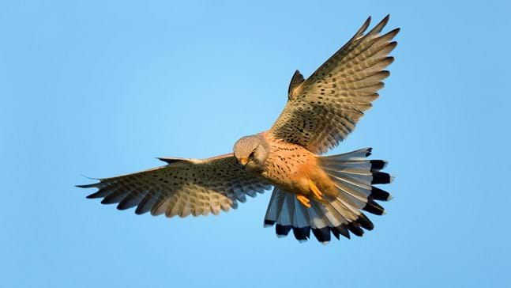

**British Value**

**Links to our**

**Curriculum Drivers**

As Writers we will develop our use of embedded clause learning to punctuate a variety of sentence structures. We will do this through story writing focusing on a story called Kidnapped.

As Readers we will read and appreciate The Boy at the Back of the Class.

As Mathematicians we will develop our understanding of written methods for multiplication and division. We will also develop our understanding of statistics and how to interpret graphs. Next we will move onto fractions.

As Scientists we will study Earth and Space.

As Historians we will explore what life was like in Tudor England.

As Geographers we will locate some of the World’s well know volcanoes and earthquake zones.

As Artists/design technologists we will improve our mastery of printing with a focus on Hokusai.

As Musicians we will learn to play the ukulele with a focus on Christmas carols.

In PE we will focus on health and fitness as well as football.

In RE we will focus on what it means to be a Muslim in Britain today.

In French we will focus on a unit called French monster pets where we will develop our ability to extract information from French texts.

Visit from MP Philip Dunne.

People and culture – Boy at the Back of the Class.

Safer Schools workshop with the police.

Enterprise week – developing and inspiring young entrepreneurs.

Performing in the church at Christmas.

Smiling Minds –mindfulness for children once a week with research showing the following benefits: improved memory, focus, mood and emotional regulation.

Effective Contributors:

Confident Individuals:

Successful Learners: Mindfulness activities to improve focus and relate to learning in class.

Responsible Citizens:

Safe and Nurtured: Safer schools workshops and Smiling Minds.

Included and Respected:

Healthy and Active:

Achieving potential:

* **People and culture**
* **Social responsibility**
* **Broadening horizons**

Understanding what we mean by British values.

**Enrichment**

**Subject Intent**

**Curriculum**

Autumn 2

**Trips, Visitors and Experiences:**

**Class Texts:**

**Enjoying and Achieving Together**