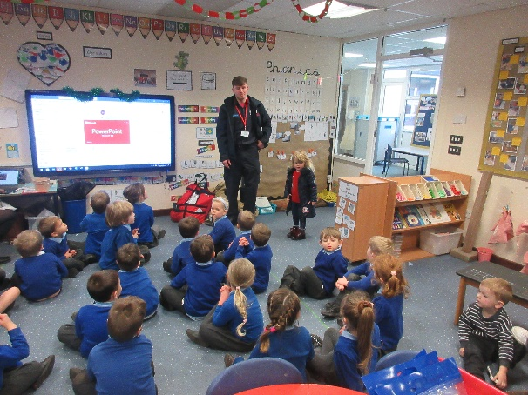
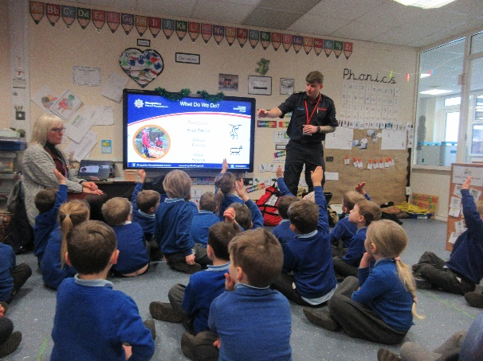
Monday 5th December 22
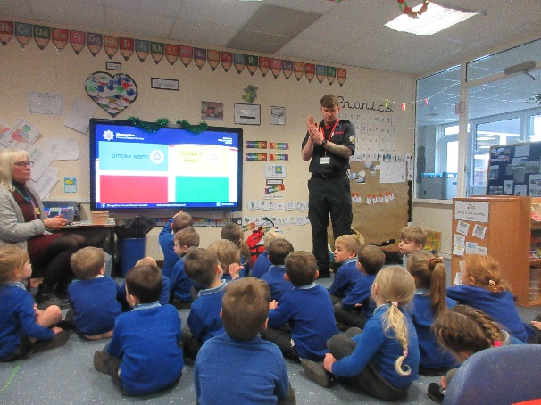
You have to put water on a fire.

Do you drive the fire engine?

Today we welcomed Scott a local Fireman into Fox Class. He told us about what he needs to help him when he has an emergency. He also told us how to keep safe at home and what to do if there was a fire.
He then dressed Mrs Martin in his protective clothing and explained why he has a helmet, boots and a thick coat.
It stops you getting burnt,
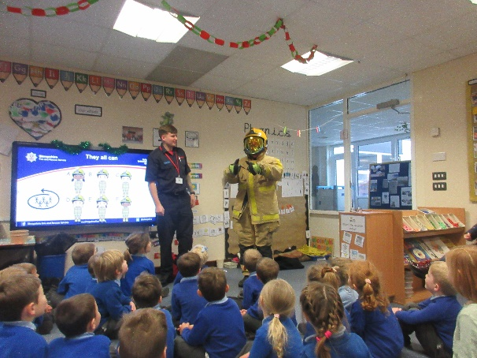

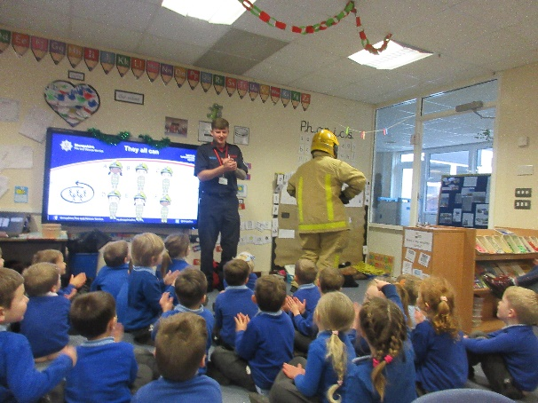
Please can you come again.

