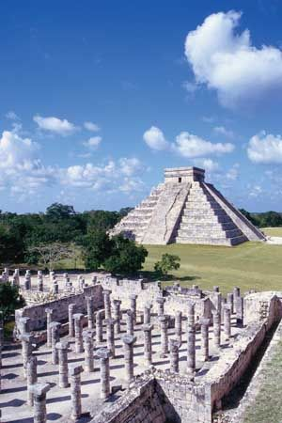Ancient Maya

Homework Project

The Maya are [Indigenous peoples](https://kids.britannica.com/kids/article/Native-Americans-or-American-Indians/353288) of [Mexico](https://kids.britannica.com/kids/article/Mexico/345743) and [Central America](https://kids.britannica.com/kids/article/Central-America/352936). Between about 250 and 900 ce the Maya had a way of life that was very advanced for the time. The Mayan civilization began a fast decline after 900. No one knows for sure why this happened.

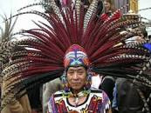You have 4 optional pieces of homework to complete, each has a reward of 5 Dojos and a bonus reward of 10 dojos for the completion of all 4 pieces. Homework is set on Tuesday 5th November and is due in on Monday 16th December 2024.

The Mayans were great farmers and enjoyed eating tortillas filled with cooked vegetables! Can you design your own Mayan tortilla recipe? Perhaps you could even make it!

Can you design and create your own Mayan headdress? Write a paragraph about why they wore them.

The Mayan’s loved chocolate. Can you find out about how chocolate is made? Draw a flow chart to show the process of making chocolate. You could use pictures and diagrams to help.

What were the Mayan warriors like? Can you draw a picture of one? Write about who they were and what weapons they had.

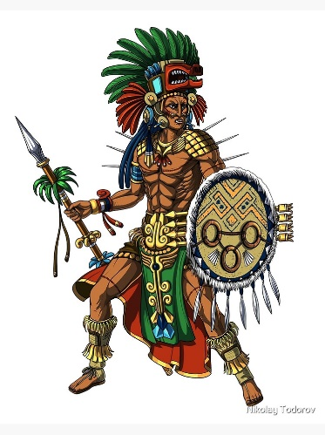

Just for fun: https://mayas.mrdonn.org/games.html